IDEA#3

Part 1

# Regular Expression (All keywords except symbols, Comments & Numbers)

Pattern|DerivedFrom|TrueFor|Else|I(ty|fity)|S(ity|ifity|rap|can)|conditionof|C(wq|wqSequence)|Valueless|Logical|BreakFromThis|Whatever|R(espondwith|equire)

Initial NFA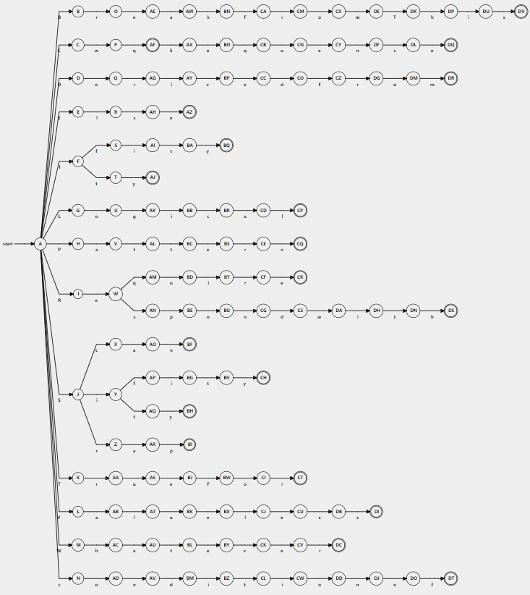

# NFA with epsilon

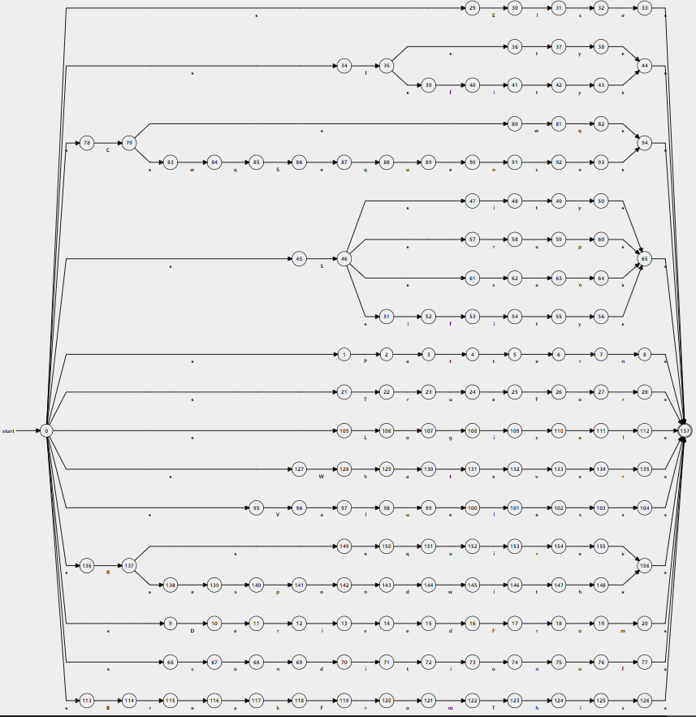

# DFA

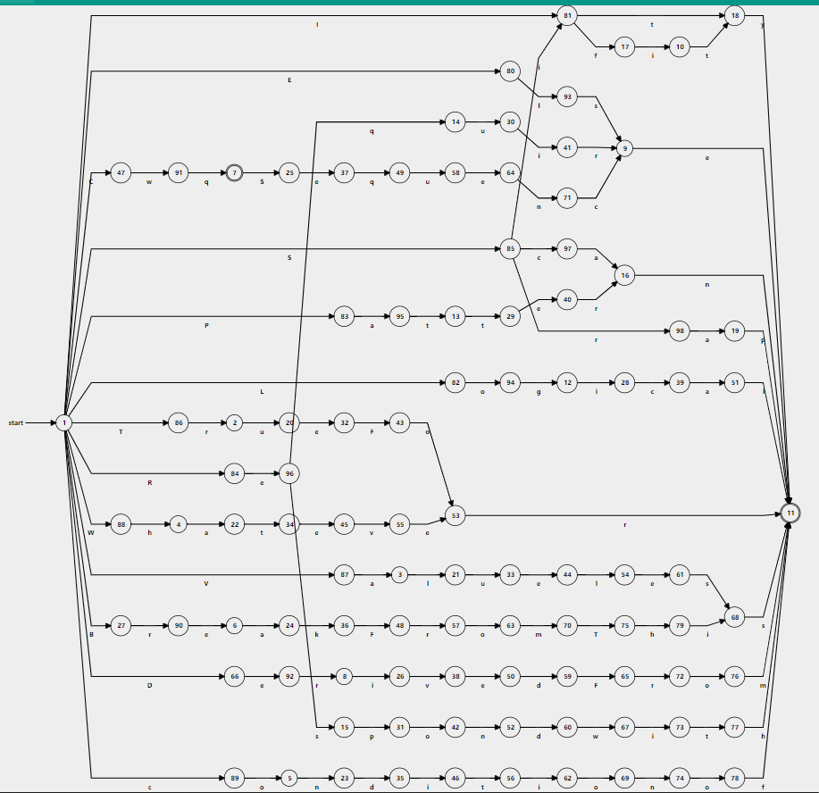

# DFA Transition Table is in Excel attachment (part1.xlsx)

Part 2

# Regular Expression (Identifiers, Symbols, Comments, Numbers & Require file Command)

* Regular expression for identifiers is **(**_|[a-Z]**)(** _|[a-Z]|[0-9]**)**\***(**, **(**_|[a-Z] **)** **(**_|[a-Z]|[0-9] **)**\***)**\*
* RE for single line Comments is --[^\n\r]*[\n\r]
* RE for multiline comments is /-.*?-/
* RE for symbols and numbers [0-9]|@|$|\+|-|\*|/|&&| \(||) |~|==|<|>|!=|<=|>=|->| \{\} | \[\] |”|’|#|^
* RE for Require file command is Require\s(_|[a-Z]|[0-9])*

# DFA for identifiers

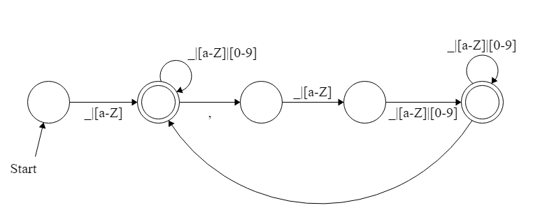

5

4

3

2

1

|  |  |  |  |  |  |
| --- | --- | --- | --- | --- | --- |
|  | LETTER | DIGIT | Underscore | Comma |  |
| 1 | 2 |  | 2 |  |  |
| 2 | 2 | 2 | 2 | 3 | accepting |
| 3 | 4 |  | 4 |  |  |
| 4 | 5 | 5 | 5 |  |  |
| 5 | 5 | 5 | 5 |  | accepting |

# NFA for single line comment

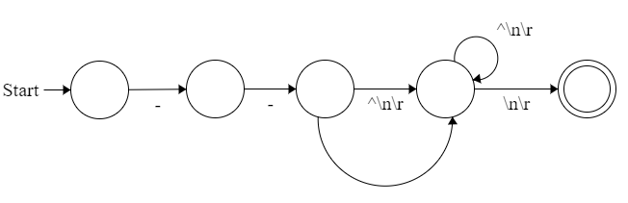

5

4

3

2

1

|  |  |  |  |  |  |
| --- | --- | --- | --- | --- | --- |
|  | - | ^\n\r | \n\r | Nothing |  |
| 1 | 2 |  |  |  |  |
| 2 | 3 |  |  | 4 |  |
| 3 |  | 4 |  |  |  |
| 4 |  | 4 | 5 |  |  |
| 5 |  |  |  |  | accept |

# NFA for multiline comment

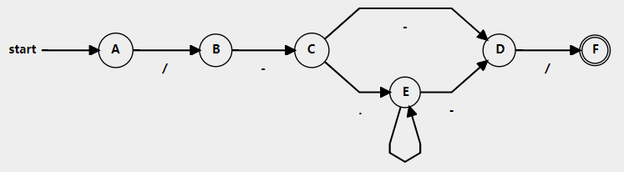

# DFA for multiline comment

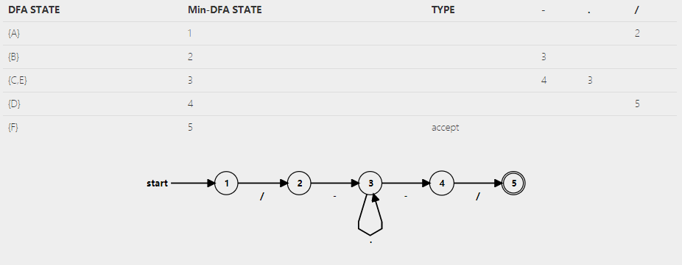



# DFA for Require file command

_|[a-Z]|[0-9]

